**Digital Logic Design**

**Assignment**

**Name: Muhammad Istafa Malik**

**Section: BS(CS)-2A**

**Roll: P19-0033**

1:

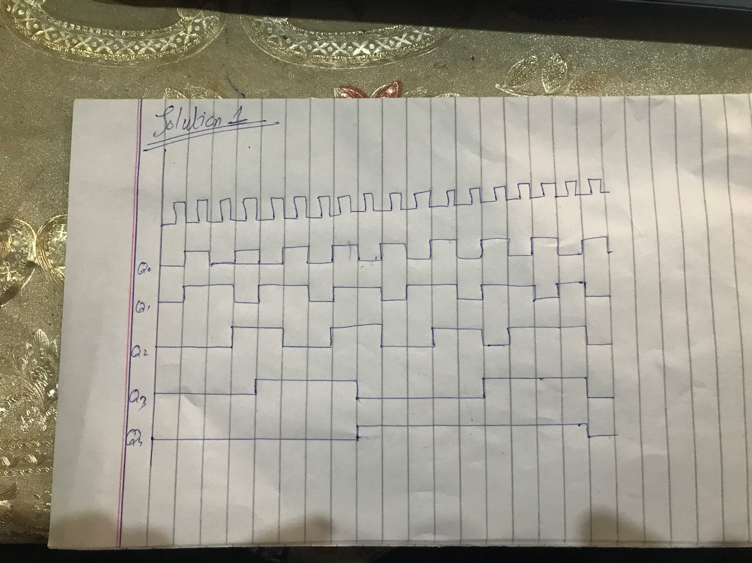

2(a):

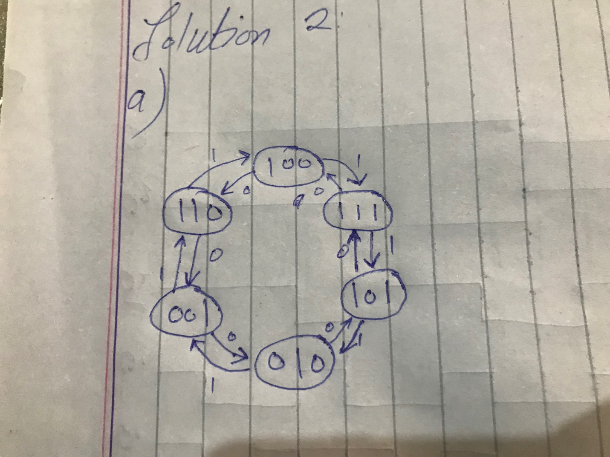

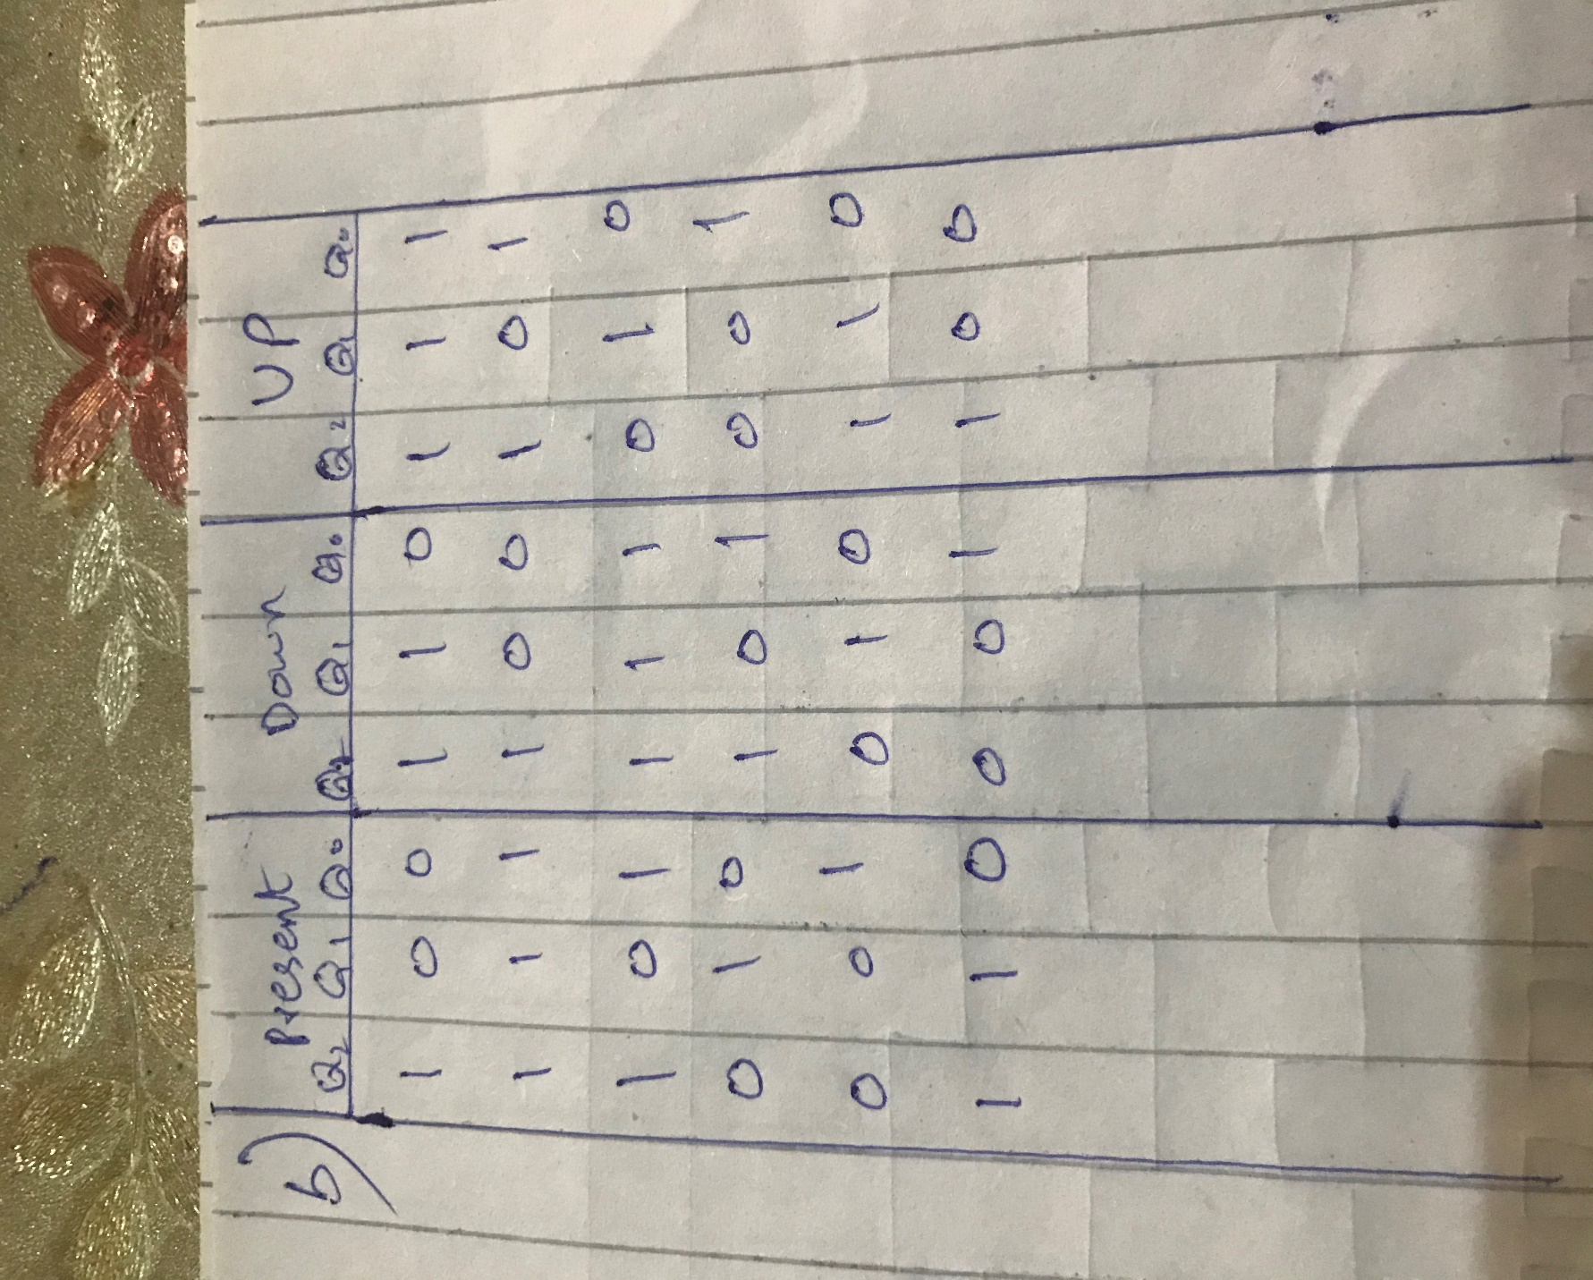**2(b):**

**2(c):**

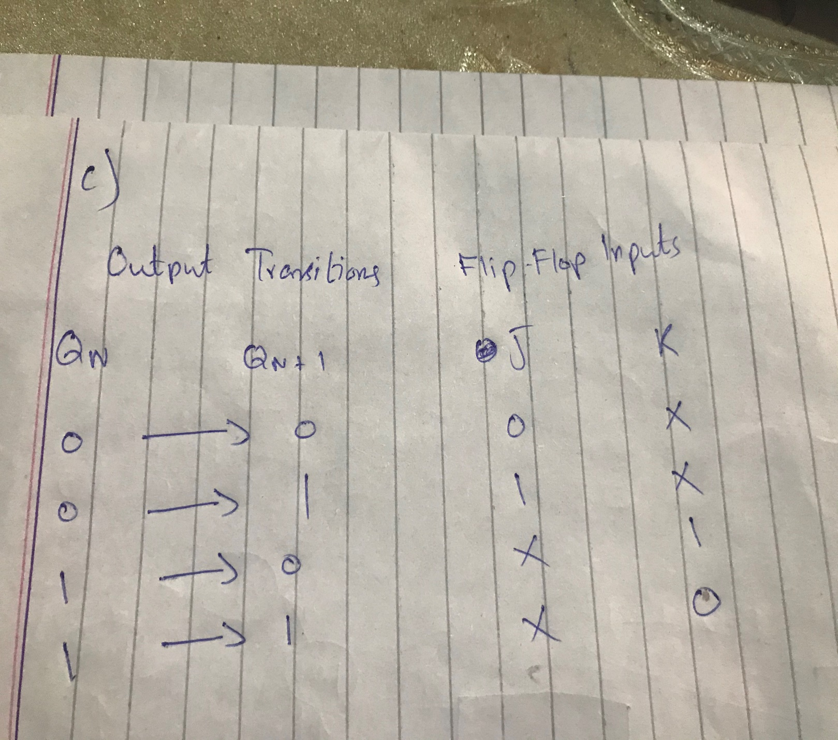

**2(d):**

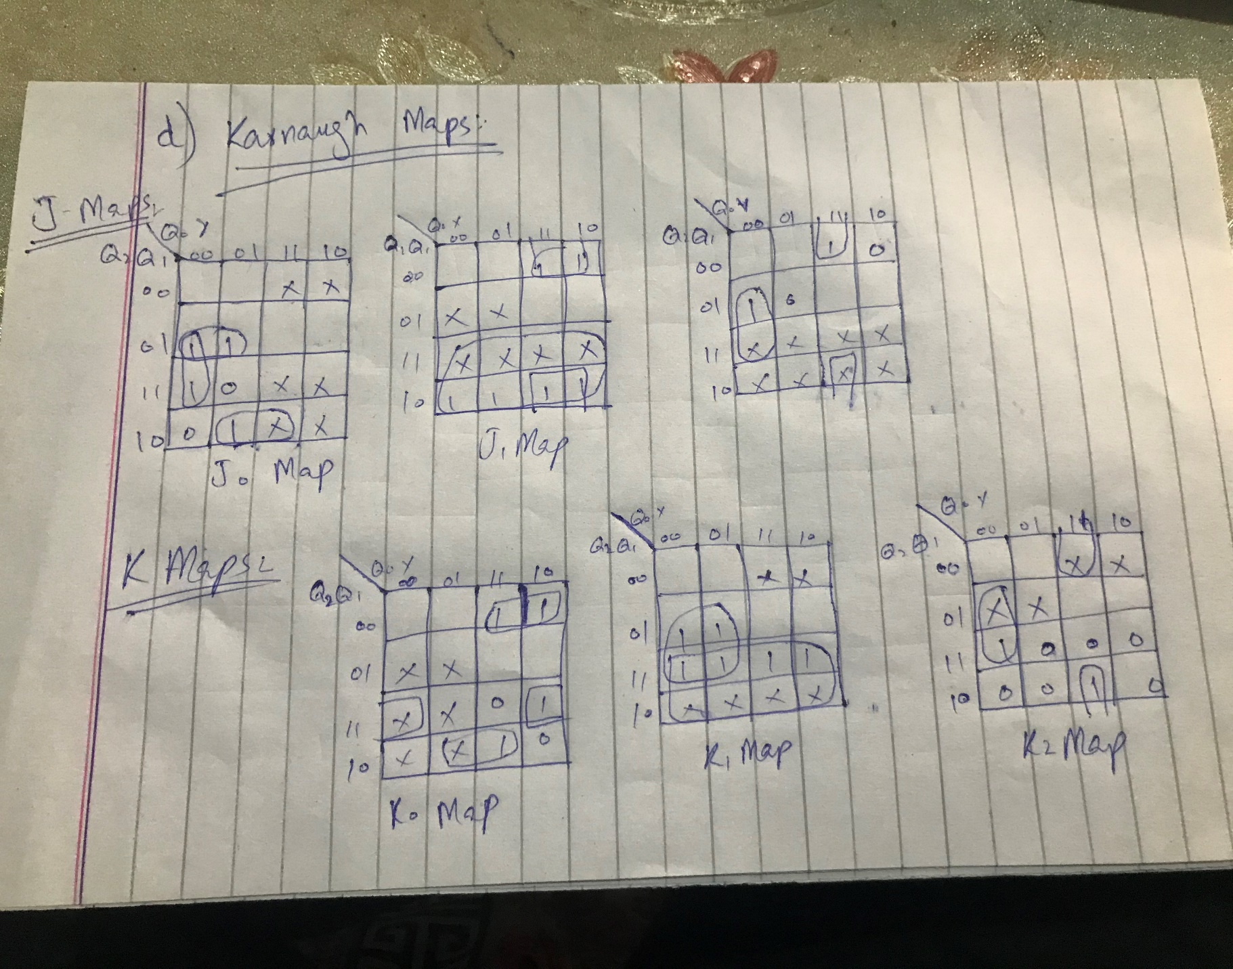

**2(e):**

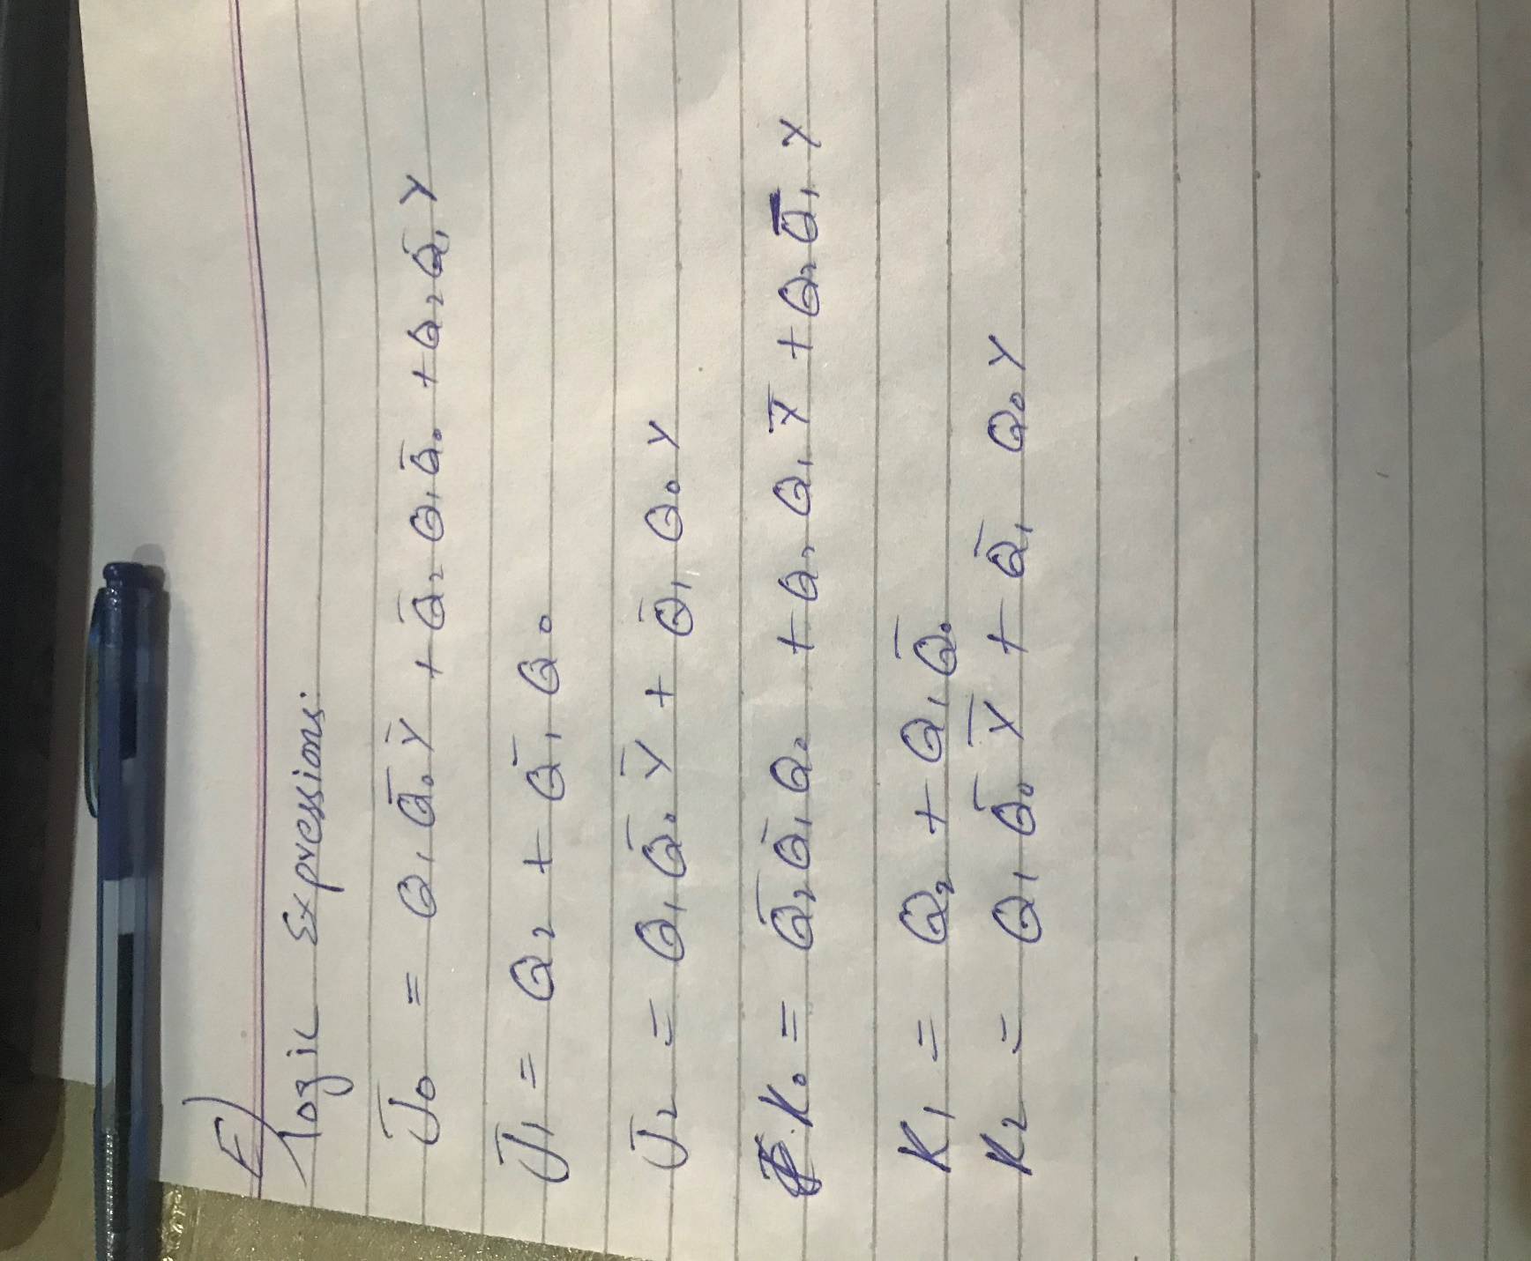

2(f):

